

Our Services and Charges

We are a Financial Planning and Wealth Management business, focused on helping you understand and plan for your financial future. This information is designed to give you an idea of:
- What we do and how we do it (our services)
- What it’s likely to cost and how you can pay us

This document provides details about our services to you and how we charge, so it’s important that you read it fully. If there is something you don’t understand please ask us to explain.
If you would like this document in larger print or in another format, please contact us.

We offer independent investment advice. This means that we consider a wide range of financial strategies and products. We are constantly reviewing the market to ensure that the services and products we offer are appropriate for our clients.
Where we recommend particular investment strategies and products to you, these will be selected based on your personal circumstances, financial goals and objectives. We’ll consider a number of factors, including the services you need, the cost of investing, how much risk you are prepared to accept in an investment product and how much of a drop in its value you could withstand.
The areas we can advise on include:
- Unit trusts & OEICs | - Venture capital trusts
- Investment trusts | - Enterprise investment schemes
- Exchange traded funds | - Business Property Relief
- ISAs | - Trusts
- Investment bonds | - Inheritance Tax
- Pensions | - Structured products
- Phased retirement & income drawdown | - Structured deposits
- Annuities | - Long term care
- Life assurance | - Residential mortgages
- Critical illness cover | - Buy-to-let & commercial mortgages
- Income protection | - Equity Release

We don’t provide advice in relation to individual share holdings. If this is something you need assistance with, we can refer you to a stockbroker. Nor do we provide advice on options, futures and other derivative contracts.
Where we provide protection planning services we are an insurance intermediary and will provide advice which is based on a fair and personal analysis of the market.

Our Services
Our services divide into 3 categories:

- Financial Planning (Including Cashflow Analysis)

Our Financial Planning service will provide a written report which will examine your financial situation, project your future cashflow using various assumptions, and make suggestions as to the appropriate strategy to meet your future needs and requirements, but it will not make specific recommendations for products or investments.

- Implementation

This service will make specific recommendations for financial products and/or investments required to implement the Financial Planning strategy and, if the recommendations are accepted, will process the paperwork to implement the recommendations.

- Servicing

- Financial Planning Servicing: This will provide an annual update to your financial plan, amending and adapting as time goes by so that you have a clearer idea of your projected retirement income.

- Investment Portfolio Servicing: This will provide an annual report detailing asset allocation, risk profile, investment performance; recommendations for changes of funds, wrappers (such as ISAs or pensions), Capital Gains issues and all other matters relating to the investment of your money. Where we recommend the use of an external Discretionary Fund Manager (DFM) we will issue an annual report which will cover overall returns and general suitability.

Our Charges
Fees for the services described above are as follows:

Financial Planning £1,000 to £2,000 depending on complexity

Implementation

Pensions and Investments:

Portfolio Value Initial Fee
£0 - £100,000 3.00%
£100,001 - £300,000 1.50%
£300,001 + 0.75%
(except VCT, EIS and BPR investments for clients who are not utilising our ongoing management service, for which the charge is a flat 3% subject to a minimum of £1,000).

Protection: We will receive commission from the provider; alternatively, a fixed fee can be agreed.

Mortgages: A fee of up to 1.00 % of the loan amount - £595 payable at the outset and the balance payable on receipt of Mortgage Offer. (On a mortgage of £100,000 the total fee payable would be £1,000). We may also be paid commission by the lender.

Servicing

Financial Planning: £750 - £1,000 depending on complexity

Investments:

Our Annual Fee for Investment Portfolio Advice starts at 1.5% a year for portfolios of £200,000 or less. The percentage reduces as the values increase, as per the chart below.

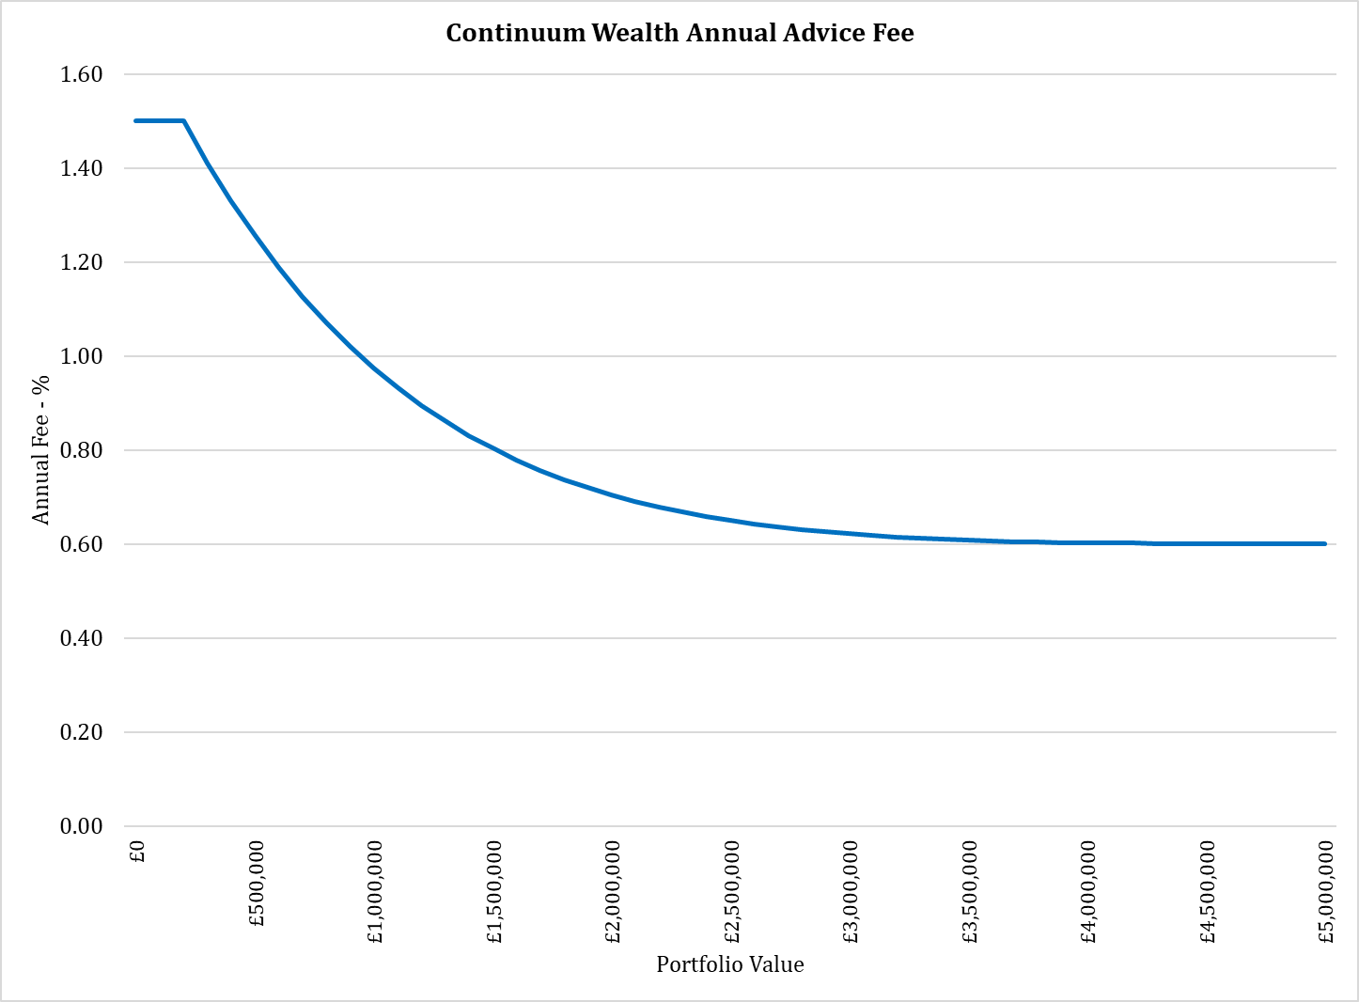

Worked examples of the charges that are quoted as percentages appear overleaf.
Under current regulations VAT is not chargeable on any of the above services.

For externally-managed DFM portfolios we charge a flat fee of 0.5% per annum of the value of the holdings.

Examples of Percentage-Based Fees

Example 1: Mr White has £120,000 to invest. His initial fee will be:

£100,000 x 3.00% = £3,000
£ 20,000 x 1.50% = £ 300
Total £3,300

His annual fee will be:

£120,000 x 1.50% = £1,800 a year

Example 2: Ms Green has £350,000 to invest. Her initial fee will be:

£100,000 x 3.00% = £3,000
£200,000 x 1.50% = £3,000
£50,000 x 0.75% = £ 375
Total = £6,375

Her annual fee will be:

£350,000 x 1.37% = £4,795 a year

Example 3: Mr & Mrs Pink have £1,325,000 to invest. Their initial fee will be:

£100,000 x 3.00% = £ 3,000
£200,000 x 1.50% = £ 3,000
£1,025,000 x 0.75% = £ 7,688
Total = £13,688

Their annual fee will be:

£1,325,000 x 0.85% = £11,313 a year

(The annual fees will fluctuate in line with the value of the investment.)

Aggregated Costs and Charges
Please note that these charges are separate from the charges levied by fund managers, investment platforms and other product providers. When we advise you, we will add together all the costs and charges payable so that you are able to understand the overall costs of our services and recommendations. This is referred to as aggregated costs and charges information.

